1)WEBSITE :-

;- A Website is a collection of web pages.

;-That is identified by common domain name and Published on at least one web server.

;-Websites are typically dedicated to a particular topic or purpose, such as news, education, commerce, entertainment

;-it must be stored or hosted on a computer connected to the Internet round a clock. .

2)DOMAIN :-

;-A domain name is your website’s equivalent of a physical address.

;-A Domain is controlled by one particular company that has its own internet presence and

ip address.

;-A domain name is your website’s equivalent of a physical address. It helps users find your site easily instead of using its internet protocol (IP) address.

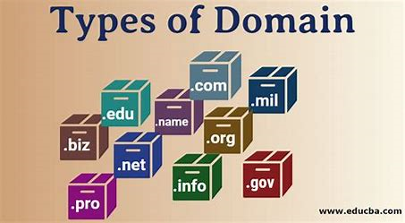

3)WWW :-

;-World wide web.

;-Collection of websites or web pages stored in a web server and connected to a local computer.

;-Users can access the content of these sites from any part of the world over the internet

using their devices such as computers, laptops, cell phones, etc.

4)HTTP :-

;-Hyper Text Transfer Protocol

;- HyperText is the type of text which is specially coded with the help of some standard coding language called [HyperText Markup Language (HTML)](https://www.geeksforgeeks.org/html-introduction/). .

;- HTTP is the underlying protocol used by the World Wide Web.

;-HTTP is a base of data communication for WWW (World Wide Web).

HTTPS :-

;-Https is a secure version of Http.

;-Https stands for Hypertext transfer protocol secure.

;-It is protocol where Encrypted Http data transfers over a secure version.

;-It is protocol for securing communication between two system.eg-browser and server.

5)URL - URI/URN

;-URI means Universal Resource Identifiers

;-Uri is text which is used to identify any resources or name on the internet.

;-URI is used to indicate the location of a web resource to access the web pages. .

;-URL means Uniform resource locator..

;-when we search any Queries on google it can give multiple results which are related to a query that is called a URL.

;-URN means Uniform resource name.

6)CLIENT SERVER :-

;-**Client-server** denotes a relationship between cooperating programs in an application, composed of **clients** initiating requests for services and **servers**

**;-its basically the Client requesting something and the Server serving it as long as its present in the database.**

**;-**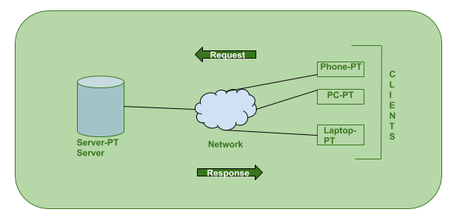

;-Client is also known as a service requestor.

7)HOST :-

;-A Person who serves or Entertains other people as guests.

;-It can either be a client or a server that sends and receives applications.

8)HOSTING :-

;-Acces your own website on Browser.

;- Websites are stored – or “hosted” – on a publicly-accessible computer (a server).

;-Host your own website so other people around you can Access it.

9)FTP :-

;-File Transfer Protocol

;- FTP (File Transfer Protocol) is used to communicate and transfer files between computers on a TCP/IP (Transmission Control Protocol/Internet Protocol) network, aka the internet.

;-.Users, who have been granted access, can receive and transfer files in the File Transfer Protocol server

10)EXTENSIONS :-

;-An Extensions is a part that is added to something that Extends or Enlarges.

;-Small software program that customize the browsing experience.

;-The main aim of an extension is to serve a single purpose around which the whole program is built.

11)PATH :-

;-Program For Appropriate Technology in Health.

;-The Address to a Specific Location or Resources within the Site Folder.

;-A Path is the list of Directories that will be searched for anything that you type on

command line.

;-A file system stores and organizes files on some form of media, generally one or more hard drives, in such a way that they can be easily retrieved..

12)EDITOR/VSCODE :-

;-A Person who is incharge of and Determines the final content of a Newspaper ; Magazine

or multi Author book.

;-Vscode means Visual Studio Code .

;-It is source code editor made by Microsoft with Electron Framework for Windows and Macos.

13)ADDRESS BAR :-

;-Address bar is the Familiar text Field at the top of web browser Graphical user interface.

;-The term **address bar** refers to the [text field](https://www.computerhope.com/jargon/t/textbox.htm) in a web [browser](https://www.computerhope.com/jargon/b/browser.htm) that identifies the user's location on the web and allows them to access different websites.

;-The address bar is known as a **location bar**, and in [Google Chrome](https://www.computerhope.com/jargon/c/chrome.htm), it's called the [omnibox](https://www.computerhope.com/jargon/o/omnibox.htm).

;-That Displays the name or the URL of the current web pages.

14)TITLE BAR :-

;-Title bar is Horizontal bar located at the top of a window in a GUI (Graphical User

Interfase).

;-It Display the Title of Software,name of the current Documentor file.

;-Title bar lies right next to the Quick Access Toolbar and it display the title of the

Currently Open Document or Application.